REQUEST TO QUOTE – PHOTOGRAHPY

Client:
Visit Peak District & Derbyshire, Commerce Centre, Millennium Way, Dunston Road, Chesterfield, S41 8ND
Project Lead:
Rachel Briody
Marketing Campaigns Manager, rachel.briody@visitpeakdistrict.com
T: 01246 212924
In Rachel’s absence, please contact amy.noton@visitpeakdistrict.com

Deadline for submissions of quote: 12noon on Friday 19th April 2024

Imagery Shoot Brief
Visit Peak District & Derbyshire and Visit Derby Photography
____________________________________________________________

The Peak District, Derbyshire & Derby
The Peak District and Derbyshire is a diverse and vibrant destination. It is the home of Britain's original National Park, with a wide variety of accommodation and exciting experiences. A place to refresh and recharge, with adventures to suit everyone from gentle ramblers to adrenaline junkies.
It is a place of wild peaks and rugged moorland with views that stretch forever. A place of chocolate-box countryside villages, with the prettiest cottages and cosy pubs. A place of castles and stately homes, welcoming market towns, and delicious local cuisine.
A place for surprising discoveries, hidden gems and heart-pumping experiences. A place that has everything.

Derby is the UK's most central city with a diverse and vibrant community. The people of Derby are its greatest cultural asset, with a diversity of backgrounds, knowledge and ideas, creating a rich cultural mix.
Derby’s new vision is the ‘city of revolutions’ - visitors can get active, explore creative activities, escape the pressures of everyday life and learn about landscapes, cultural heritage and wildlife.

Brief Overview
We are looking to produce a set of images that showcase the distinct personalities of the Peak District & Derbyshire and Derby City – whilst highlighting the close proximity of the city to the Peak District and surrounding Derbyshire countryside, offering the best of both worlds.
Minimum 5 day shoot with 4 days in the Peak District & Derbyshire and 1 day in the city.
We would be open to purchasing existing images from your portfolio if you have suitable images that fit the requirements.

Example Imagery
Images should be shot wide with a mix of landscape and portrait shots to accommodate a range of formats and most should include people, all of whom need to have signed releases. Those featured should be unposed and casting should focus on diverse talent that feel warm and welcoming. Images should be identifiably British while also showing something unexpected – attraction, food, casting or location.

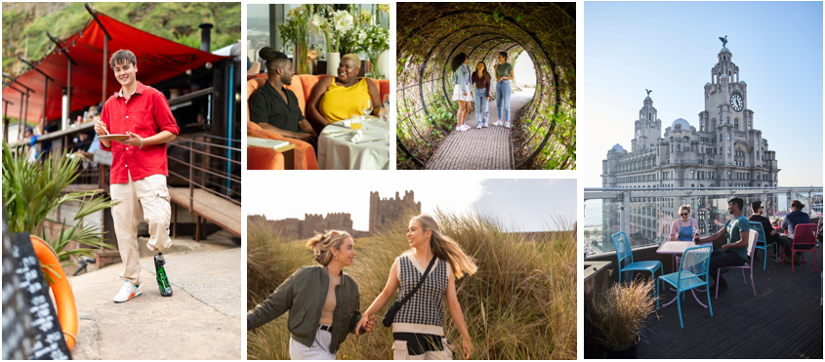

Usage
Copyright assignment or non-exclusive licence which permits:
- Global usage
- All media
- In perpetuity
- 3rd party usage
- Waiver of moral rights
Supporting documentation required for above use:
Consent type | Description
Model release | Consent for each person featured in the image. This includes talent, waiters, stall holders, people in background behind main talent. Public must not be featured in images if unreleased.
Property release | Consent for each property featured in the image to include materials or artworks on or in the property.
Artist Licence | Consent direct from the artist for the artworks featured in the image
Film Permit | Approval from the local Council that permits filming at agreed locations.
Filming notice | Filming in public places or events may require a filming notice which details the filming and purpose and a contact name and mobile number for public to contact should that have any concerns or requests.

Considerations
- Quantity – we need to cover a range of locations and key imagery inside and outside rather than getting a breadth of shots in a single set up.
- Releases – all property, model and artist releases must be obtained. Anyone recognisable must provide a signed release. Crowd notices are not sufficient.
- Alcohol – where an alternative is possible (eg pub/restaurant) please capture options with coffee or a soft drink as some countries have restrictions on use of alcohol imagery.
- Peak District Proud – ensure that all images adhere to the countryside code, no wild camping, dogs must be kept on leads and no barbecues in the National Park.

Deliverables
- The assumption is that Visit Peak District, Derbyshire and Derby will be given contact sheets showing images and thumbnails from which to make selects.
- Option choice is desirable eg: A choice of viewpoints, scenarios (ie with or without people, with or without alcohol)
- Shoot wide or provide format choices that work for design and advertising purposes ie vertical, horizontal or panoramic

- Photography
  - Up to 100 stills per day

- Asset rights support
  - Scan and deliver all releases.
  - Retouching support to remove any branding or unreleased individuals.

- Quality control
  - Model pool should be diverse and inclusive
  - VPDD to select models from a potential talent pool

Mandatories
- No branding on clothing eg trainers, bags, jackets. Or when shooting in public places eg main focus on big brand signage.
- No single use takeaway plastic

Casting / Wardrobe
- Diversity in models is required. Ideally different models for different locations to add variety but if this is not possible within budget limitations / logistics please advise.
- Models must be vetted ahead of shooting.
- Colourful clothing where possible. Models can wear own clothes although no branding on any garment including shoes.

Locations

Treak Cliff Cavern and Blue John Stone – internal cavern shots with diverse visitors exploring as well as external views

Derwent Dam, Ladybower Reservoir – long shots of the Dam and reservoir as well as sink holes and close up views of the overflow

Bamford – visitors on edge with classic views in background

Hathersage – village shots highlighting the classic stone cottages and other points of interest

Matlock Bath – high street shots – highlighting the colourful houses and steep hills, fun icecream and fish & chips

Peak District National Park images with people in – Mam Tor, Kinder, Edale

Derby City events and city centre images that reflect ‘revolution’ both literally and metaphorically to include Sadler Gate Spring Market, Cathedral Quarter shopping, Museum of Making, Electric Daisy, Darley Abbey Mills, Derby Breweries and Derby Theatre.

A member of the Visit Peak District & Derbyshire and Visit Derby team will accompany you on two recce days prior to the shoot and where time allows on location as part of quality control. We would also like to see the talent selection and have full sign off prior to the shoot.

Key timings
- Contract awarded end of May 2024
- Mid June 2024 - all work needs to be completed by 30th June 2024

Budget
The budget for this activity including any travel expenses is £13,500 inclusive of VAT
Any expenses claimed must be accompanied by receipts and proof of purchase must be provided upon request.
Payment of invoices – invoices will be paid with 30 days.

Appendix

Additional location references

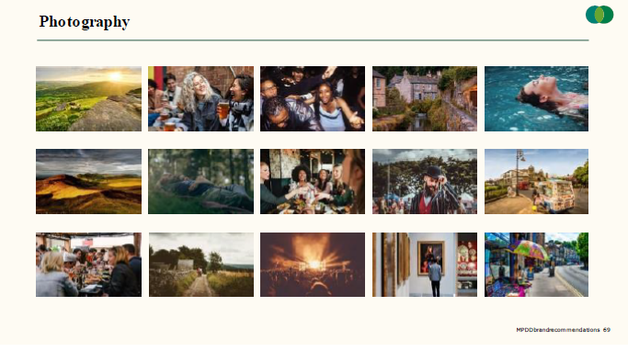

Delivery Specification
- File naming convention: LVEPNAME_yearmonthday_PhotographerName_Location_filenumber E.g. LVEPNAME_220824_PhotogarpherName_ Location_001.jpg
- File size: RAW file exported to JPEG at high quality setting maximum 12MB
- File format: .JPG
- Resolution: 300ppi
- Colour space: Adobe RGB (1998)
- Aspect Ratio: 3:2
- Processing: Natural processing free of unwanted colour casts. Images must not appear overly manipulated.
- Calibration: Post processing carried on regularly calibrated monitor (calibration using a hardware device is recommended)

